BluetoothTM 5.0 USB Dongle
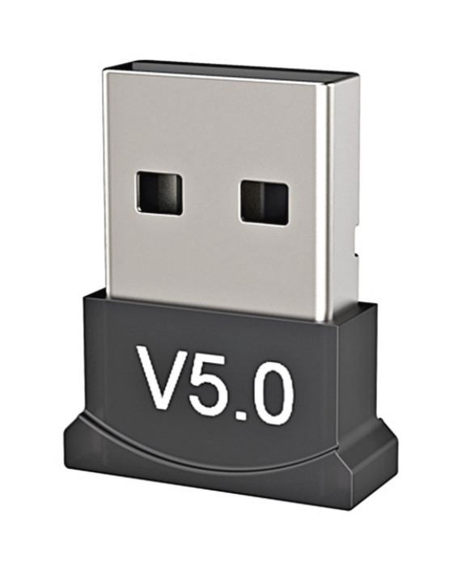
BT-USB-V-G

DESCRIPTION
- Bluetooth v5.0
- Support Window7 8.10/Vista/XP,Mac OS X
- Wireless devices such as a keyboard, mouse, speakers, headsets, printers,gamepads & more
- Universal serial usb interface，usb 2.0 I 3.0/4.0
- Receiving / sending range : 10- 20m

Features
- Bluetooth low energy wireless usb adapter
- Dual-mode bluetooth transmission
- Iow power consumption
- Support bluetooth voice and data
- Support multi language
- Wireless local area network share interface

